Comparing various tone mappying operators to measure compression and performance
High dynamic range image performance

Bilal Rabbani 15030017
LUMS CS-Department, Lahore, Pakistan
Sarwan Ali - 16030030
LUMS CS-Department, Lahore, Pakistan

Moeen Ud Din - 15030008
LUMS CS-Department, Lahore, Pakistan

Introduction
High-dynamic-range photographs are generally achieved by capturing multiple standard exposure images, often using exposure bracketing, and then merging them into a single HDR image

High-dynamic-range imaging (HDRI) is a high dynamic range (HDR) technique used in imaging and photography to reproduce a greater dynamic range of luminosity than is possible with standard digital imaging or photographic techniques. This is often achieved by capturing and then combining several different narrower range exposures of the same subject matter. Non-HDR cameras take photographs with a limited exposure range, resulting in the loss of detail in highlights or shadows.

HDR image and video formats are designed to encode all luminance levels that can be found in the real world, which may vary from as low as 10⁻⁵ cd/m² (candela per square meter cd/m² is the derived SI unit of luminance) which is roughly the luminance of moonless sky, to 10¹⁰ cd/m², which exceeds the luminance of the sun. HDR formats can usually store contrast 1:10¹⁵ or dynamic range of 15 log₁₀ units, while standard formats usually do not exceed the dynamic range of 3 log₁₀ units [1]. The maximum luminance of a typical cathode ray tube (CRT) display is 100-cd/m².

Due to the limitations of printing and display contrast, acquiring an HDR image is only half of the work done; one must also develop methods of displaying the results. The method of rendering an HDR image to a printing device or standard monitor is called tone mapping.

In this paper, we study different tone mapping operator and through experiments we identify the strength and weaknesses of each operator.

Literature View
Jeena Baby (2013) show that a study of different picture differentiate improvement strategies has been finished. Shading picture upgrade assumes a critical part in computerized picture preparing. Differentiate improvement is an advancement issue and is accomplished for the pictures which are encountering low quality. Low quality of pictures is because of different components like natural lighting conditions, abandons in photographic gadgets, and so on. Thusly picture differentiate upgrade is imperative so as to enhance the human acknowledgment rate. The vast majority of the papers depend on histogram evening out procedure and its augmentations. Histogram leveling is a complexity upgrade strategy in light of the histogram of the picture. Every procedure has got its own points of interest and in addition disservices. Different complexity upgrade strategies have been proposed by various creators as an augmentation of the customary histogram balance. They are power obliged differentiate upgrade, dynamic range pressure, shading model change, gamma redress and channel division techniques. A few late papers are being studied under every method. The distinctive complexity upgrade systems were examined. Other than differentiation upgrade control requirements are likewise considered. Control sparing is a vital calculate the sight and sound gadgets. The significant issue confronted by a large portion of the pictures is clamor. Different methods have been analyzed for the picture commotion (noisy disturbance) decrease. Shading model changes are essential when the handling of RGB pictures is dreary. The vast majority of the strategies are the augmentations of the conventional histogram balance [2]. This strategy is valuable in pictures with foundations and frontal areas that are both splendid or both dim. Specifically, the technique can prompt to better perspectives of bone structure in x-ray pictures, and to better detail in photos that are over or under-uncovered. A key preferred standpoint of the strategy is that it is a genuinely clear method and an invertible operator. So in principle, if the histogram equalization function is known, then the histogram (original) can be retrieved. The count is not computationally intensive. An impediment of the technique is that it is aimless or indiscriminate. It might increase the contrast of background noise, while diminishing the usable signal.

Hojatollah Yeganeh and Zhou Wang (May 2013) proposes a tone mapping approach in which search is carried out in the space of images to find better quality images in terms of a recent objective measure instead of explicitly designing a new computational structure for Tone mapping operators (TMOs). This technique can assess the structural fidelity between two images of different dynamic ranges. Especially, starting from any initial image, the algorithm moves the image along the gradient ascent direction (climbing minimum to maximum) and stops until it approach to a maximal point. A TMO approach has been designed by making use of objective structural fidelity measure approach. The proposed approach does not start from a different computational structure for tone mapping. Instead, it explicitly treat tone mapping as an optimization problem in the image space and propose an iterative search approach. This approach starts from any initial image and moves step-by-step in the image space towards the direction of improving the structural fidelity measure. The process is done until a (local) maximal point is reached. When applied to initial images generated by existing and state-of-the-art TMOs, the algorithm enhances the visibility of image details almost every time and improves the structural fidelity measure. Indeed, it often restores image structures that are missing in the images produced by other TMOs approaches [3]. The drawback of this approach is that this technique can work in limited domain. As according to J. Baby and V. Karunakaran “a study of different picture differentiate improvement strategies has been finished”, therefore we cannot extend this approach further. Minor adjustments can be made but we cannot rely on those results only. Some computational changes also have to be made. The advantage of using this technique is that it is easy to use as compare different images have less margin for error are doing computational work.

Ma, Kede (2015) tone mapping operators (TMOs) intend to pack high dynamic range (HDR) pictures to low dynamic range (LDR) ones in order to envision HDR pictures on standard presentations. Most existing TMOs were exhibited on particular cases without being completely assessed utilizing very much planned and subject validated picture quality evaluation models. An as of late proposed tone mapped image quality index (TMQI) made one of the primary endeavors on target quality evaluation of tone mapped pictures. Here, they have proposed a significantly unique way to deal with outline TMO. Rather than utilizing any predefined efficient computational structure for tone mapping, (for example, expository picture changes and additionally unequivocal difference/edge upgrade), they specifically explore in the space of all pictures, hunting down the picture that advances an enhanced TMQI. Specifically, they first enhance the two building hinders in TMQI—basic devotion and factual expectation parts—prompting to a TMQI-II metric. They then propose an iterative calculation that on the other hand enhances the auxiliary loyalty and measurable expectation of the subsequent picture. Numerical and subjective tests show that the proposed calculation reliably delivers better quality tone mapped pictures notwithstanding when the underlying pictures of the emphasis are made by the most focused TMOs. Then, these outcomes likewise approve the predominance of TMQI-II over TMQI [4]. The drawback of this approach is that it have to do a lot of computation which require more computation power. But on the other hand, better results are obtain. Our goal is to achieve the better results keeping the computational overhead as minimum as possible.

Dominant part of computerized pictures and video material put away today can catch just a small amount of visual data noticeable to the human eye and does not offer adequate quality to completely misuse abilities of new show gadgets. High dynamic range (HDR) picture and video designs encode the full noticeable scope of luminance and shading extent, along these lines offering extreme constancy, constrained just by the capacities of the human eye and not by any current innovation. In this paper, they show how existing picture and video pressure models can be reached out to encode HDR content effectively. This is accomplished by a custom shading space for encoding HDR pixel values that is gotten from the visual execution information. They likewise show how HDR picture and video pressure can be planned so it is in reverse good with existing configurations [1].

Sujatha Ka, Dr D Shalini Punithavathanib (2016) introduces a new hybrid method has been introduced by combining two hybrid tone mapping operators (local and global operators). To achieve this, multiple images are combined into single HDR image with various global or local operators. It will give an output which is an enhanced HDR image. Enhancement map is constructed either with the threshold value or the luminance value of the pixel. Using the enhanced map, original luminance map is separated from base layer and detail layer by running bilateral filtering (noise reducing filter for images). The detail layer is used to enhance the result of global tone mapping. The performance of hybrid tone mapping is then compared to individual local and global operators and the results show that the hybrid operator gives a better performance [5]. The disadvantage of this hybrid approach is again the computational overhead. Overall this approach performs better as compares to other mentioned above but this all come with a cost which one have to pay. Our goal is to minimize that cost to a minimum extend as possible.

Proposed approach
There are different type of tone mapping algorithms proposed by different researchers. Our proposed approach is to highlight some of those approaches, analyze them and see the results to find out that which approach is better. One thing to consider is that there cannot be one ideal approach which can work efficiently in all scenarios. Therefore the purpose of our research is to find out those optimal approach which can work efficiently a maximum number of scenarios (e.g dim light, bright light etc). This will be done by implementing current approaches and by analyzing their results.

According to best of our knowledge, there are two type of approaches which are used in HDR field in which tone mapping operators are used to map HDR images to LDR images to visualize the images on standard displays.

- Computational structure for Tone mapping operator
- Comparing different low quality images taken from HDR image to get an ideal image (Without Computation) [3]
The second type discussed above works like tone operator by selecting single image with the best quality from the range of images, which can be called a best LDR image possible so that it can easily be displayed on monitor screen. As we know that while converting an HDR to LDR, there can be multiple frames which can be taken as effective LDR images from multiple one. Therefore selecting a single best image is necessary, that’s the job of “Comparing different low quality images taken from HDR image to get an ideal image”. We will analyze both of these approaches to compute an overall result which will highlight that which approach is better in which scenario.

Quality assessment techniques

A number of Image Quality measures are proposed, but none is proved to be true representative of human perception of image quality. However we will focus on two evaluation measurement techniques to analyze our results.

- Subjective evaluation [6]
- Objective evaluation
Subjective evaluation

Subjective evaluation is the most straightforward method to assess tone mapped images. This is done by investing spectral distance based and human visual system based image quality measures for their effectiveness in representing the human perception for images corrupted with white noise.

Objective evaluation

Objective quality assessment of tone mapped images is a difficult problem. Since the original HDR and the tone mapped LDR images have different dynamic ranges, typical objective image quality measures such as peak signal-to-noise ratio (PSNR) and the structural similarity index (SSIM) are not applicable.

Several objective assessment methods have been proposed for HDR images.

- HDR visible differences predictor (HDR-VDP)
- Dynamic range independent quality measure

We will use ‘Dynamic range independent quality measure’ because it is based on multiple factors which will help us in assessment. Those factors are:

- Loss of visible features
- Amplification of invisible features
- Reversal of contrast polarity

The approach which we will use in our research is hybrid approach which will be the combination of both of techniques (Computation and non-computation). As according to J. Baby and V. Karunakaran “a study of different picture differentiate improvement strategies has been finished”, therefore we will focus more on the computation technique rather than comparing different pictures to get a better quality image.

Our purpose is to perform both subjective and objective evaluation of our hybrid approach. Currently we have successfully implemented the HDR in matlab and have done the subjective evaluation. We are now working on objective evaluation while still refining our strategy. Then we will compare our strategy with different latest approaches in this field to see if we get better results than those approaches or not.

Experiments
We have studied different tone mapping operators and implemented them to study their behavior on different image datasets. Then those images are compared with a reference image to evaluate the effectiveness of a tone mapping operator.

To test the performance of the proposed method, we select a set of widely-used HDR images as test images. The initial images for the iterative algorithm are created using different approaches, including blank images (all image pixels are set to 128), linearly mapped images (direct linear scaling from the source HDR images to the dynamic range of [0,255]), and images created by state-of-the-art TMOs [2, 4, 5, 20]. It can be observed in Table 1 that starting from simple blank and linearly-scaled initial images, the proposed method successfully produces high structural fidelity images. In addition, it is also quite effective at improving upon all state-of-the-art TMOs.
Figure 1 provides a visual demonstration of the iterative procedure, where the proposed algorithm is applied to an initial tone mapped “Memorial” image created by the “Exposure and Gamma” method in Adobe Photoshop. The structural fidelity map is very effective at detecting the missing details in the tone mapped images. For example, the structural details in the brightest window region in the initial image Fig. 1(a) are completely lost due to tone mapping and are clearly indicated by the central dark region in the structural fidelity map Fig. 1(f). With the progress of iterations, such details are becoming more and more visible until nearly perfectly restored after
25 iterations as shown in Fig. 1(e). The evolvement of the structural details is very well tracked by the structural fidelity maps computed along with the iterations, which eventually converge to a nearly uniform white picture.

Table 1. Comparison of structural fidelity scores

Image | Blank image | Reinhard HDR Local TMO | Reinhard HDR Global TMO | Globally Optimized Linear Windowed Tone-Mapping
Reading table |  | 0.7713 | 0.3572 | 0.0094
KernerEnvLatLong |  | 0.7479 | 0.5002
BigFogMap |  | 0.2483 | 0.0969

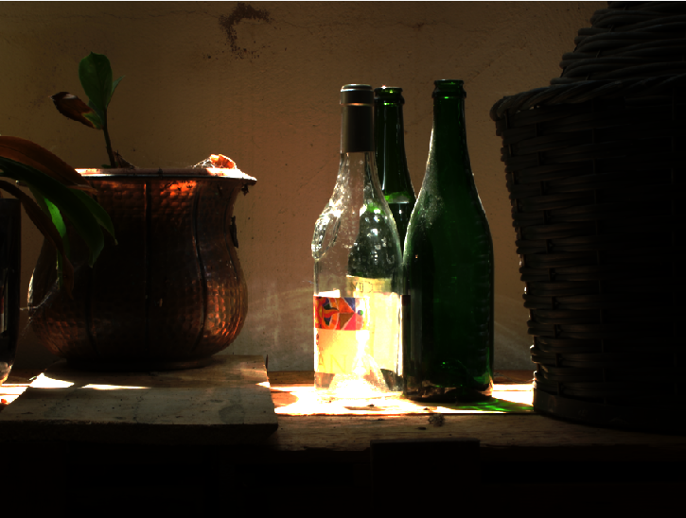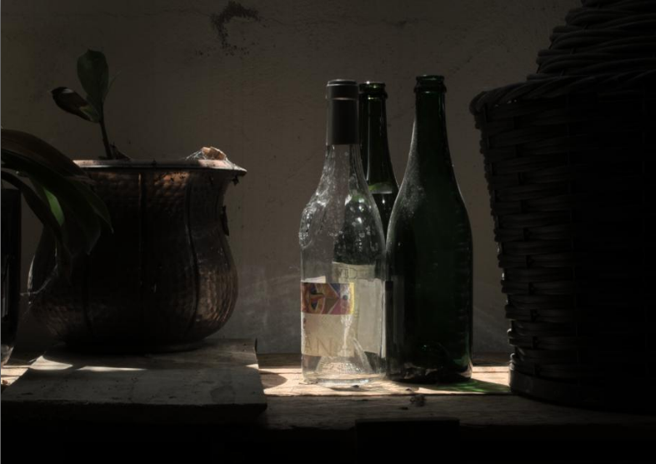
HDR Visualization
Reinhard HDR Local TMO

Figure 1: Generation of LDR image of Reading table

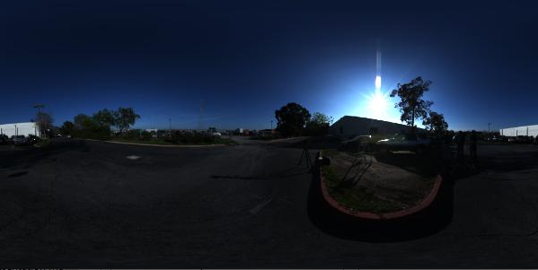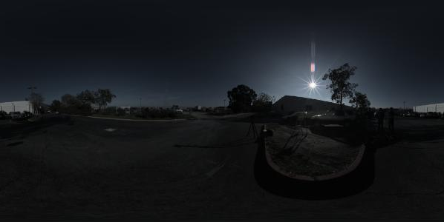
HDR Visualization
Reinhard HDR Local TMO

Figure 2: Generation of LDR image of KernerEnvLatLong

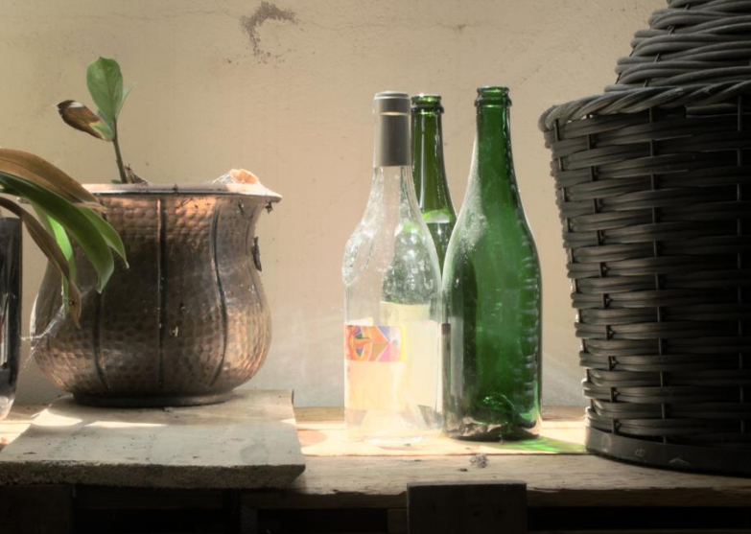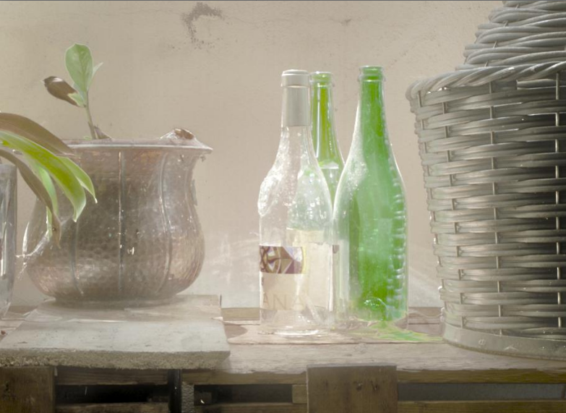
Reinhard HDR Global TMO
Globally Optimized Linear Windowed Tone-Mapping

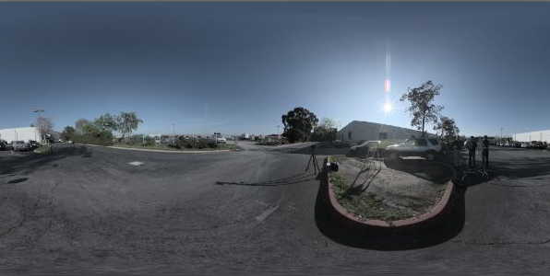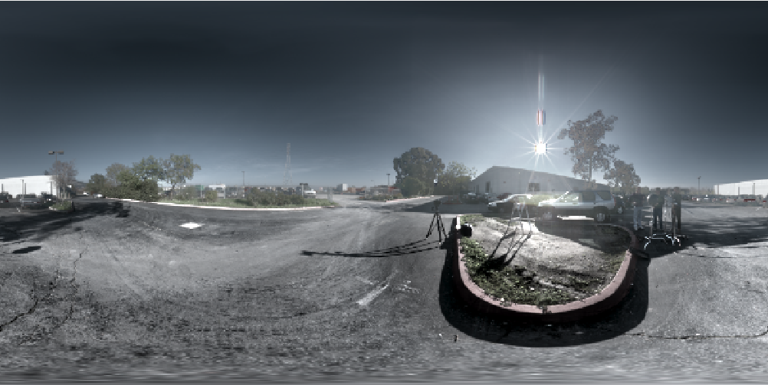
Reinhard HDR Global TMO
Globally Optimized Linear Windowed Tone-Mapping

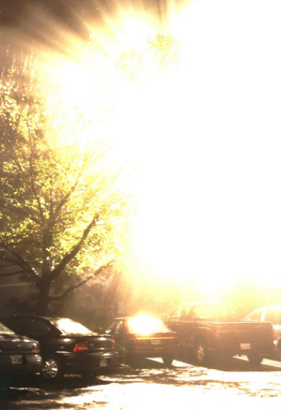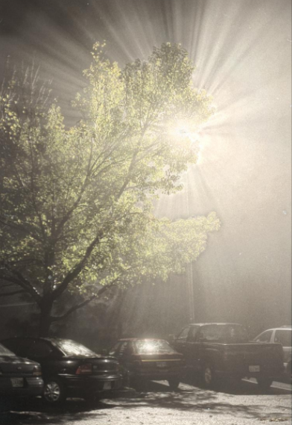
HDR Visualization
Reinhard HDR Local TMO

Figure 3: Generation of LDR image of BigFogMap

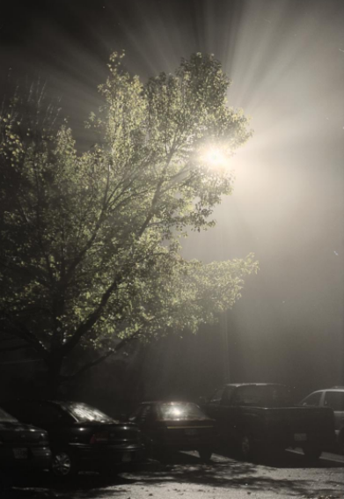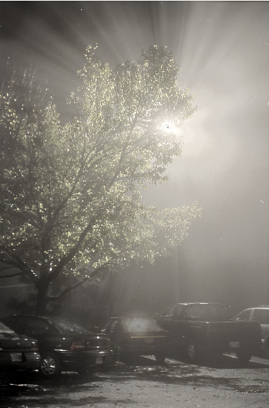
Reinhard HDR Global TMO
Globally Optimized Linear Windowed Tone-Mapping

References
- Mantiuk, Rafal, et al. "High dynamic range image and video compression-fidelity matching human visual performance." 2007 IEEE International Conference on Image Processing. Vol. 1. IEEE, 2007.
- J. Baby and V. Karunakaran, “Survey On Various Image Contrast Enhancement Techniques”, International Journal For Research in Applied Science and Engineering Technology(IJRASE T), vol. 1 no. V, (2013) December, pp. 65-69.
- Yeganeh, Hojatollah, and Zhou Wang. "High dynamic range image tone mapping by maximizing a structural fidelity measure." 2013 IEEE International Conference on Acoustics, Speech and Signal Processing. IEEE, 2013.
- Ma, Kede, et al. "High dynamic range image compression by optimizing tone mapped image quality index." IEEE Transactions on Image Processing 24.10 (2015): 3086-3097.
- Sujatha Ka , Dr D Shalini Punithavathanib.” Local and global tone mapping operators in hdr image processing with amalgam technique.” Sujatha et al., International Journal of Advanced Engineering Technology
- Mansoor, Atif, and Adeel Anwar. "Subjective evaluation of image quality measures for white noise distorted images." Advanced Concepts for Intelligent Vision Systems. Springer Berlin/Heidelberg, 2010.

